- Create one IAM user and assign ec2, s3 full access role.
- Log in to your aws ccount
- Go to the IAM
- Create user
- Give the user name and click next
- Set permissions there are three options available
  - Add user to group : Add user to an existing group, or create a new group ehich has permissions already assigned to it so the new user can use it by adding user in group.
  - Copy permissions : to copy permissions or inline policy that has been already attached to existing user
  - Attach policies directly : to create policies and attach to the user.
- Select the attach policies : in you have customer managed policies and aws managed policies
- Customer managed : create the policy and use for the user
- Aws managed : the policies that are already created by aws it self to give permissions and acess.
- For now select the policy by searching for ec2
- Select amazonec2 full acess
- And also search for s3 and select fullacess to s3

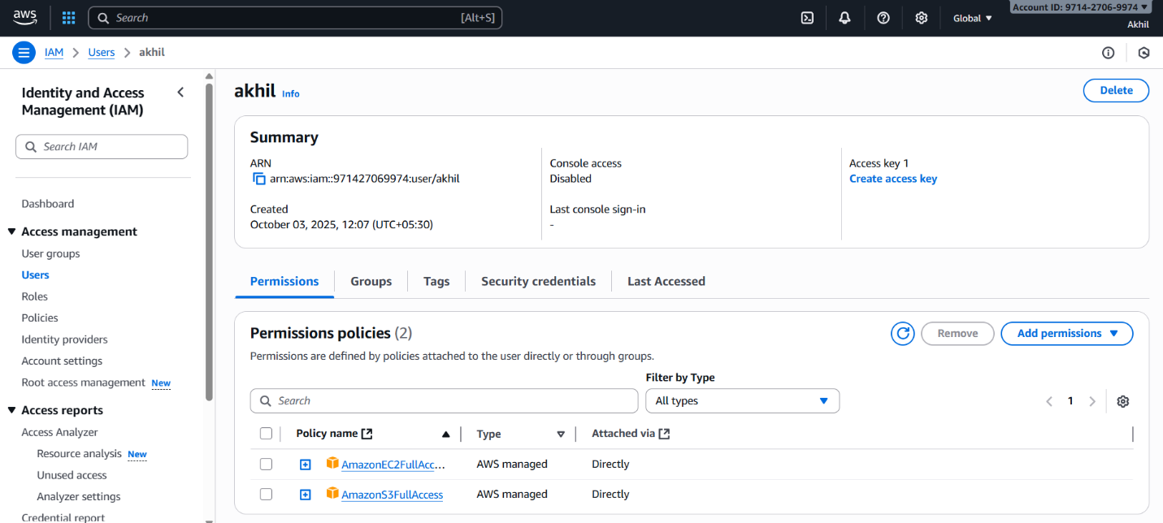

- Create one Group in IAM and Assign Read access for ec2.
- Go to IAM user groups
- Create group – provide user group name
- Then create user – ad policy of ec2 read only acess and create the user group
- The user group with the read only access for ec2 has been created
- After creating the policy
- Go to the user groups create user group –add the ec2 read only policy to the user group
- Now the user group is created with the read only policy of ec2

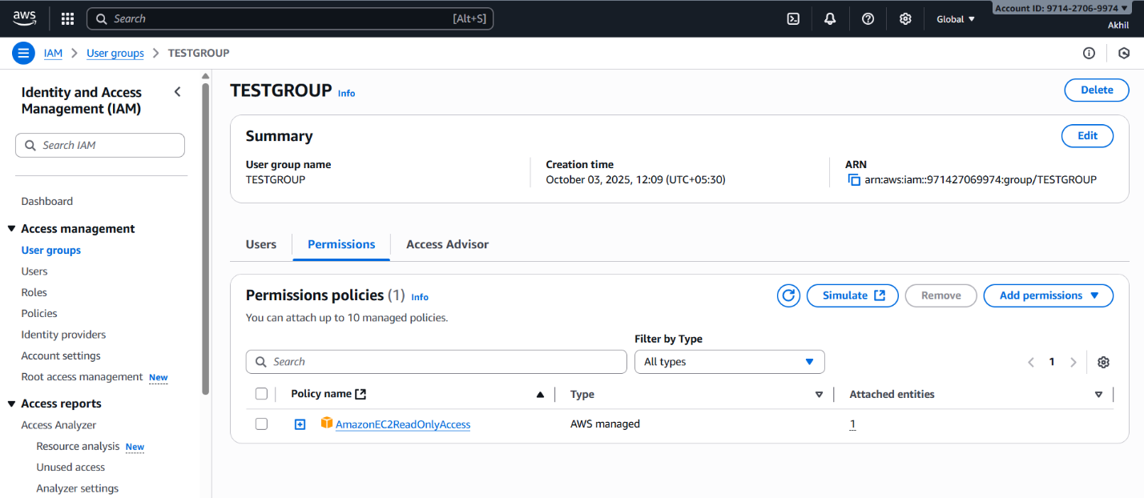

- Create a new user with name Devops and add to the group created in task2
- Create the user with the user name devops donot attach or create the policy then add the user in the user group—select created so that it can aceesthhe [permissions created in the group automatically
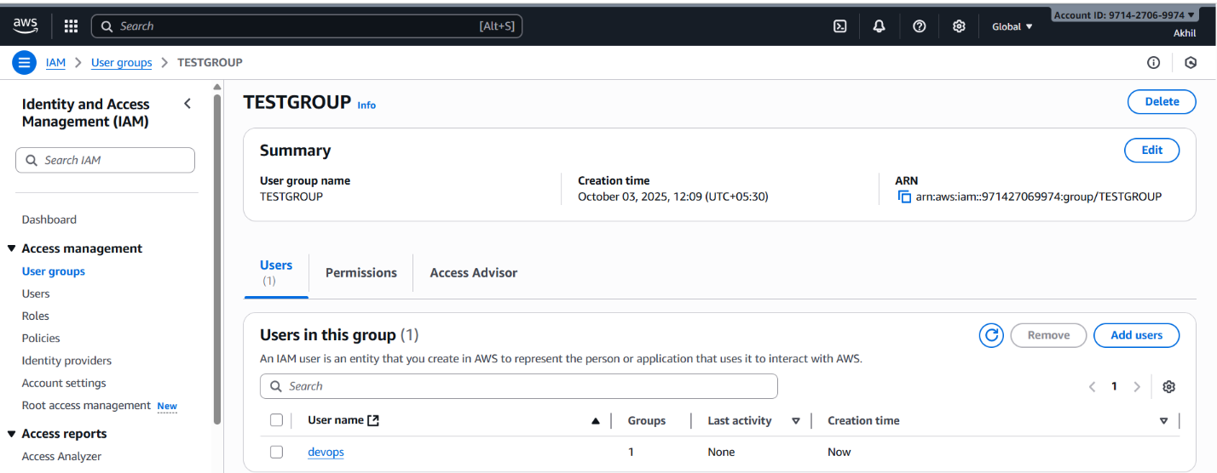

- Write a bash script to create a IAM user with VPC full access.
- Connect to ec2 instance
- Aws configure
- Provide acess key and secret key , ouput format ,region

#!/bin/bash

aws iam create-user --user-name "$1"
aws iam attach-user-policy --user-name "$1" \
--policy-arn arn:aws:iam::aws:policy/AmazonVPCFullAccess

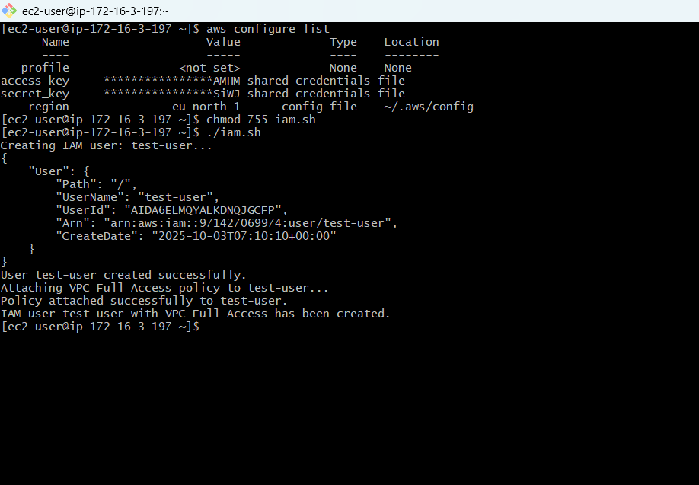
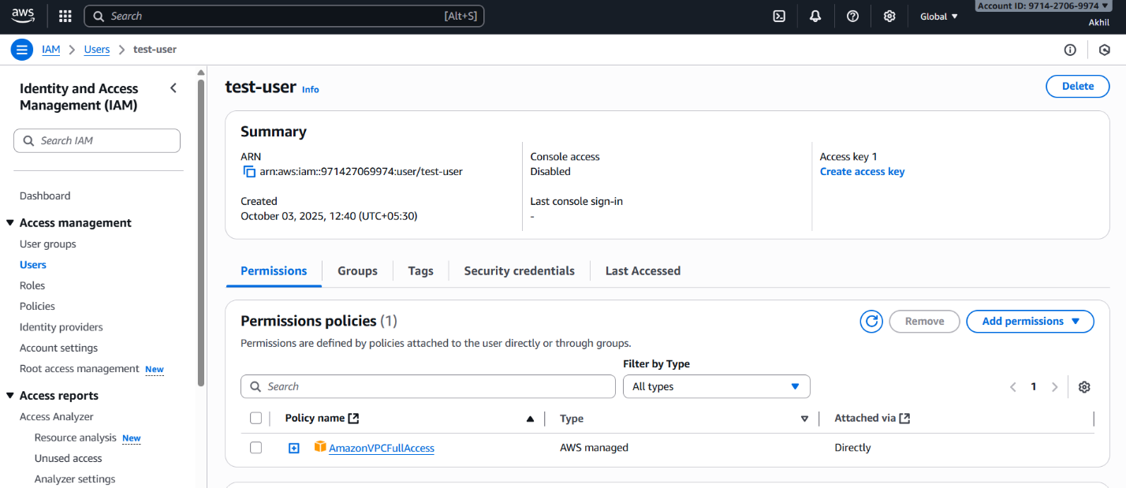

- Create a IAM policy to access ec2 for a specific user in specific regions only.
- Create user
- Select iam
- Custom password create password
- Next click
- Then provide the ec2 full acess policy to the user then create the user

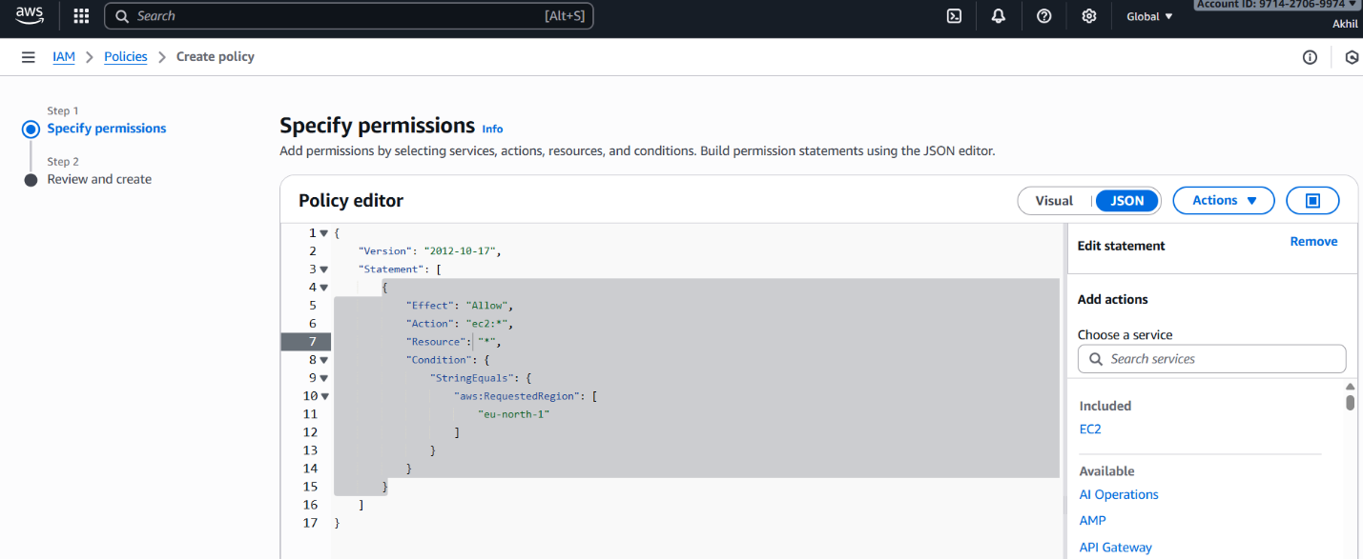
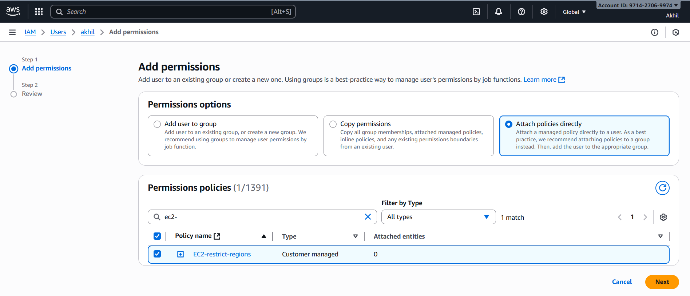

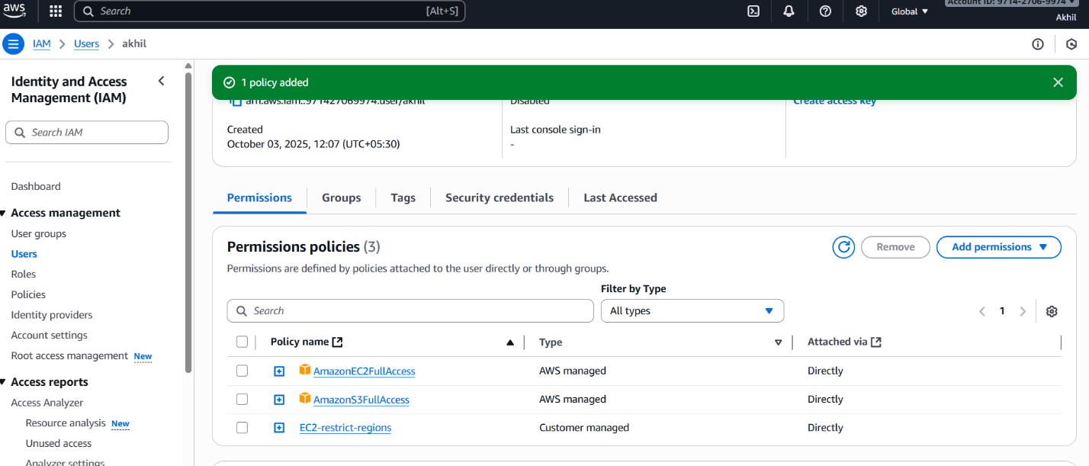
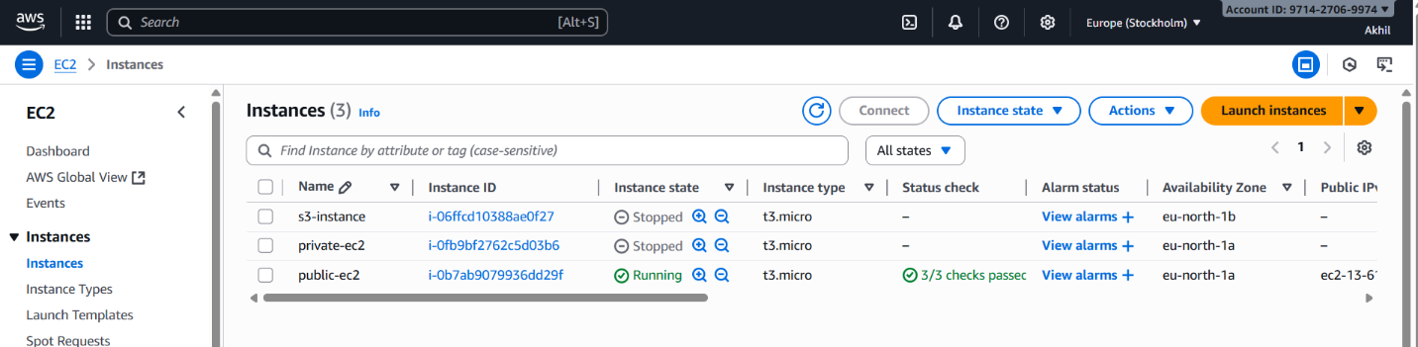

6) We have two accounts Account A and Account B, Account A user should access s3 bucket in Account B. (Collaborate with team member and execute this.Mostly asked in every interview)

